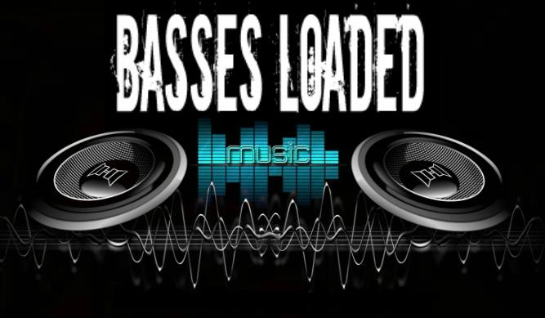

Wedding DJ Timeline Checklist

Hello! Thank you for downloading our worksheet. We took the experienced knowledge and notes we have learned through weddings we have done. The result is a very useful tool on what we feel works the best to help you communicate with your DJ. This makes sure your reception is a successful stress free event. Full of lasting memories, dance, good times and fun. Just how you envisioned your wedding day to be.

Your wedding specialists!
DJ SAX

To use this document:

Customize the document (bold underlined areas) to reflect your own schedule, names, phone numbers, and directions as needed to reflect your personal info.
Modify the remaining sections of the checklist to reflect the music you want on your Big Day.
Email or Print this out and give it to your DJ.

Wedding of
Jane Doe and John Smith

January 1, 2014

DJ Worksheet

Primary Contact Person At Venue:
Julie Jones – Any questions or problems about music or order of events should be directed to this person, who knows the Bride and Groom’s wishes.

Contact info:

555-555-1234 Bride’s cell phone
555-555-2345 Groom’s cell phone

Location / Directions:

The reception will be at Name of venue brief directions

Wedding Day Schedule:

1:30 DJ set up sound check completed
2:00 Pre ceremony music starts guests arrive (*DJ starts now*)
2:25 Wedding party walks down the aisle (Groom and Officiate are in place)
2:30 Bride enters the room and proceeds down the aisle
2:35 Ceremony begins
3:00 Ceremony ends
3:15 Cocktail hour begins
3:15 Photography starts (1 hour)
4:30 Bridal party arrives at reception (see announcement details below)
4:35 Reception events (see detailed list below)
8:00 Reception ends

Reception Events

Led and announced by the DJ. Timing is up to DJ to determine based on what is happening at that time, Things do not always follow the time line as exactly planned. The actual order of events is up to you. The timeline below is what we find to work best for reception flow, at least from the experience of the weddings we have done.

- Blessing (if you choose to please give persons name John Doe)
- Dinner starts
- Toast (sometimes done before dinner starts)
- Bride and Groom’s first dance (sometimes done right after grand entrance)
- Bride dances with her father
- Groom dances with his mother
- Money Dance (you may choose to have one or not)
- Dance floor is open to all (about 20 minutes)
- Cutting of the cake Cake is served
- Bouquet and garter toss
- Dance floor open

Announcement of Bridal Party:
Bridal party members will enter as couples.
Announce the names only (roles are provided in parentheses for reference only).

Mr.and Mrs. Names (Parent of the Bride)
Mr.and Mrs. Names (Parent of the Groom)
Name of Groomsman & Bridesmaid (Attendants)
Name of Groomsman & Bridesmaid (Attendants)
Name of Groomsman & Bridesmaid (Attendants)
Name of Groomsman & Bridesmaid (Attendants)
Names of both (Best Man and Maid of Honor)
Their names (Ring Bearer and Flower Girl)

Exactly how you want to be announced (Bride and Groom)

Special Event Songs:

EVENT | Artist | Song
During Bridal Party announcements
During Bride and Groom’s grand entrance
Bride and Groom’s
First Dance
Bride dances with her father
Groom dances with his mother
Cake Cutting
Bouquet Toss
Garter Removal

Dollar Dance (if you choose to have one)

Artist | Song

Must be played during the Open Dance portion of the reception.

Artist | Song

Must NOT play these songs:
Under NO circumstances, even by guest request, should these songs be played:

SONG | ARTIST

General Music Styles we Like/Dislike:

MUSIC STYLE | WE LIKE IT | WE DISLIKE IT
Country
Pop Top 40
Oldies (50s and 60s)
Classic Rock (60s and 70s)
80s Rock / Pop
Rap
R&B
Heavy Metal
Jazz
Alternative Rock
Big Band
Disco
Hip Hop
Reggae
Punk
Techno
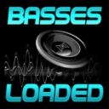
Check out our website for help on song ideas
http://bassesloaded.weebly.com/wedding--music--ideas.html
If you need more info or help call us 716-661-3840

